Harta cu tronsoane

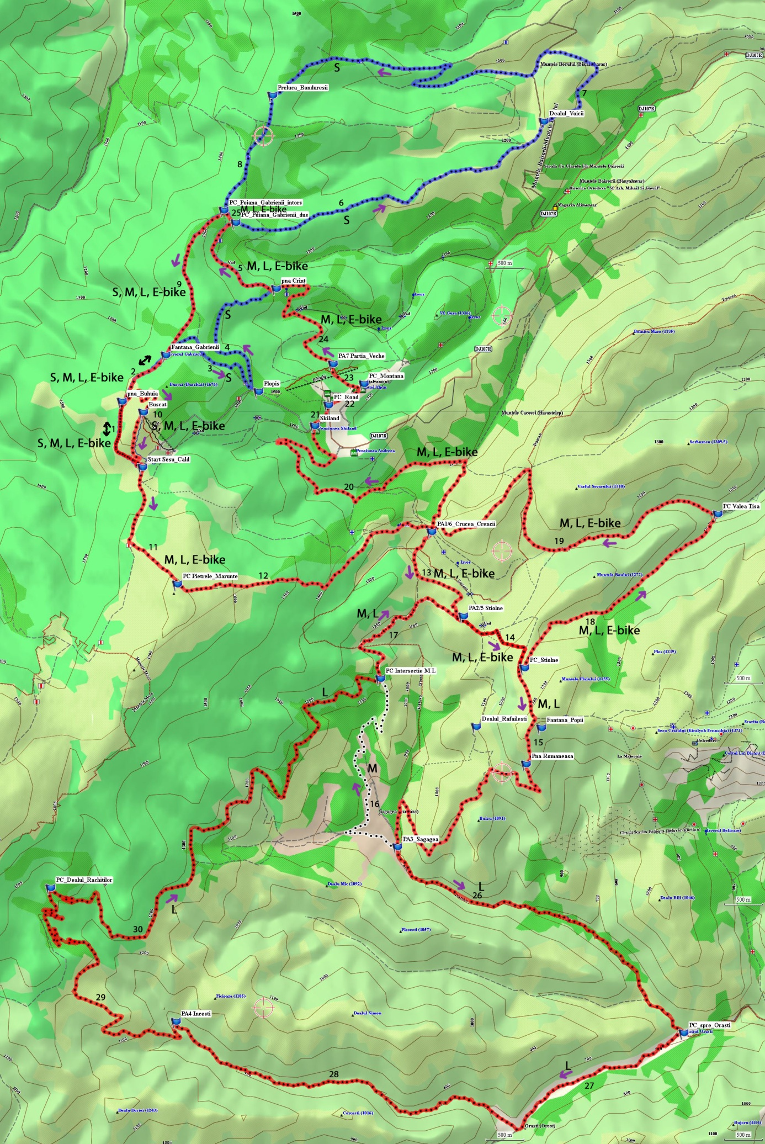

Tabel tronsoane

|  |  |  |
| --- | --- | --- |
| **Numar tronson** | **Sensuri tronson** | **Trasee care il contin** |
| **1-9** |  | **traseu scurt S** |
| 1 | dus-intors | S, M, L, E-bike |
| 2 | dus S, intors S, M, L, E-bike | S, M, L, E-bike |
| 3,4,6,7,8 | dus, in ordine crescatoare | doar S |
| 5,9 | dus, in ordine crescatoare | S, M, L, E-bike |
|  |  |  |
| 10-14 | dus, in ordine crescatoare | M, L, E-bike |
| 15 | dus | M, L |
| 16 | dus | M |
| 17 | dus | M, L |
| 18-25 | dus | M, L, E-bike |
|  |  |  |
| 26-30 | dus | L |
|  |  |  |